**MINI ENIGMA**

Date: 12-05-2016

Course: Computer programming

Instructor: Dr. Goldie Gabrani

**Project Description**

Program takes a key and then encodes a given line of message to send as a method of secure communication, later to be decoded by the receiver.

**Outline Solution**

It will ask for key, text to be send and will show the encoded and decoded message respectively.

**Design**

IN this first a title page displaying the name of the program is displayed using for loops and gotoxy function, after that by pressing any key, the program further displays a page with two menus :

1. Encode a given text
2. Decode a received text

This is a menu driver function whose option is selected by switch case. The programs futher works depending on the input of the user.

**Software & Hardware Requirements**

Compiler: Dev C++

Operating system: Windows 8.

**Concepts Used**

This step contains the file that is used in the whole program. In this step the use of header files are as follows:

1. Stdio.h

This stands for standard input and output. This describes stdin, stdout, stdprn and stderr stream which shows the path and level of input and output.

It includes:-

1. Scanf() :scans and formats input from the stdin stream
2. Printf() :writes formatted output in stdout.
3. Fclose() :closes a stream
4. Fopen() :opens a stream
5. Fflush() :flushes a stream
6. Fwrite() :write to a stream
7. Fread() :read to a stream
8. fGets() :gets a string from striding
9. fputs() :outputs a stringto stdoutput
10. windows.h

windows.h is a Windows-specific header file for the C/C++ programming language which contains declarations for all of the functions in the Windows API, all the common macros used by Windows programmers, and all the data types used by the various functions and subsystems.

It includes:

1. gotoxy() :positions the cursor to a specific coordinate in the x-y plane.
2. String.h

The string.h header defines one variable type, one macro, and various functions for manipulating arrays of characters.

It includes:

1. Strlen() :gives the length of a string
2. Strcpy() :copies contents from one string to another
3. Strcat() :concatenates one string into another
4. Conio.h

conio.h is a C header file used mostly by MS-DOS compilers to provide console input/output. It is not part of the C standard library or ISO C, nor is it defined by POSIX. This header declares several useful library functions for performing "console input and output" from a program.

It includes:

1. Getch() :halts the screen until any key is pressed
2. System(“cls”) :clears all the contents in the screen
3. System(“color”) :colors either the text or background depending on the parameters passed.

**Testing & Validation**

In this project testing is not required and is valid for correct data entered. (Ex: “age: 10” but not “age: abs”)

**Testing Material**

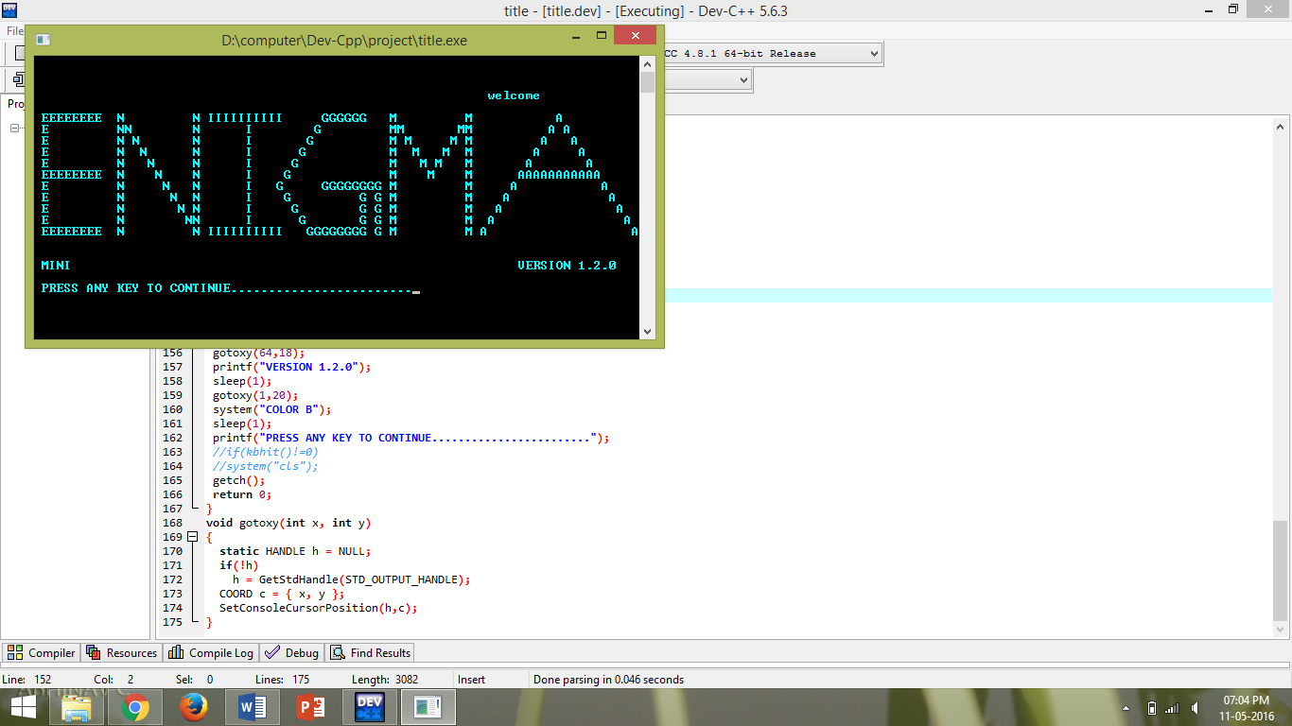

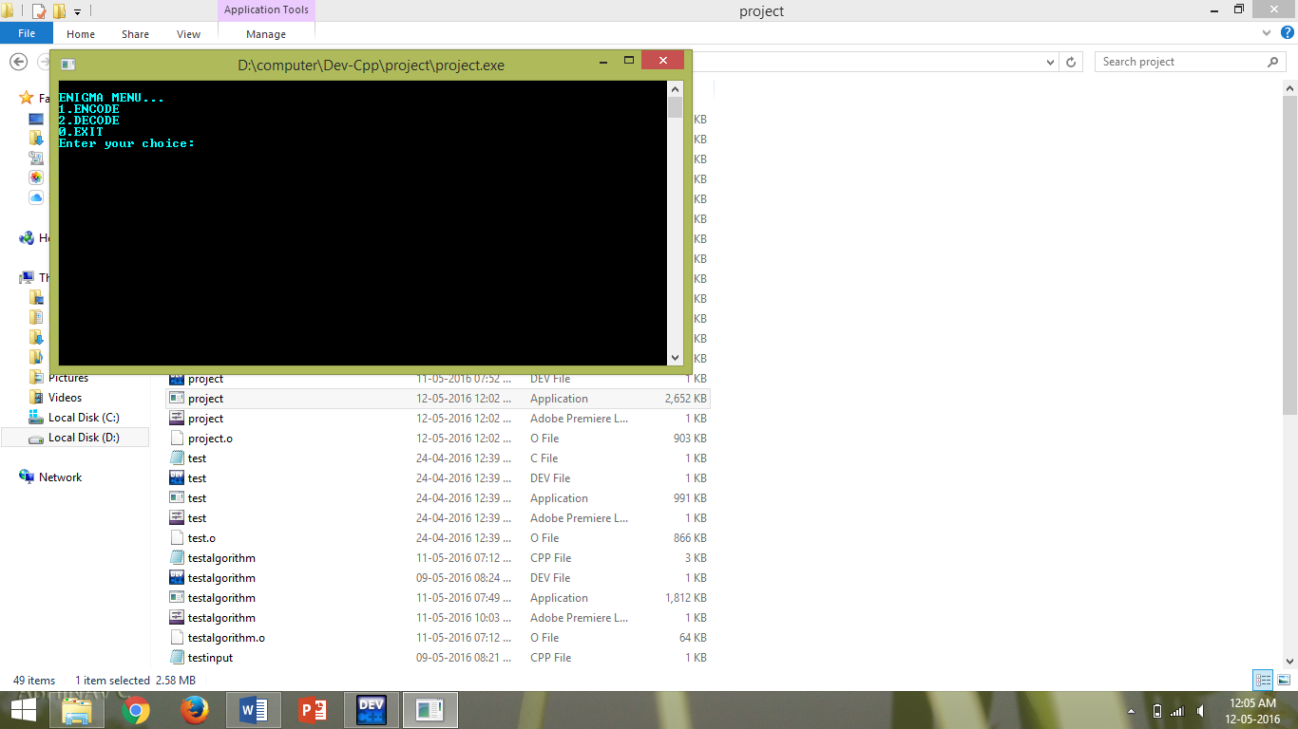

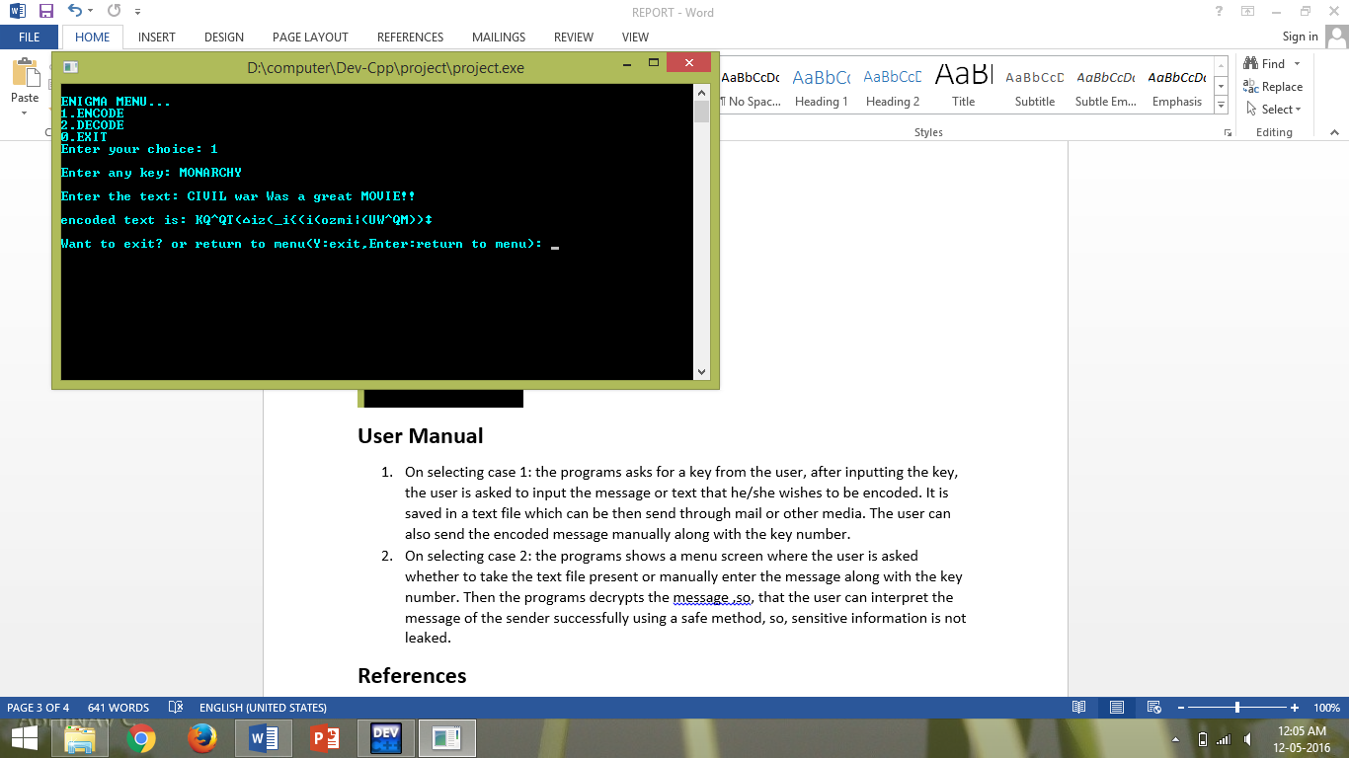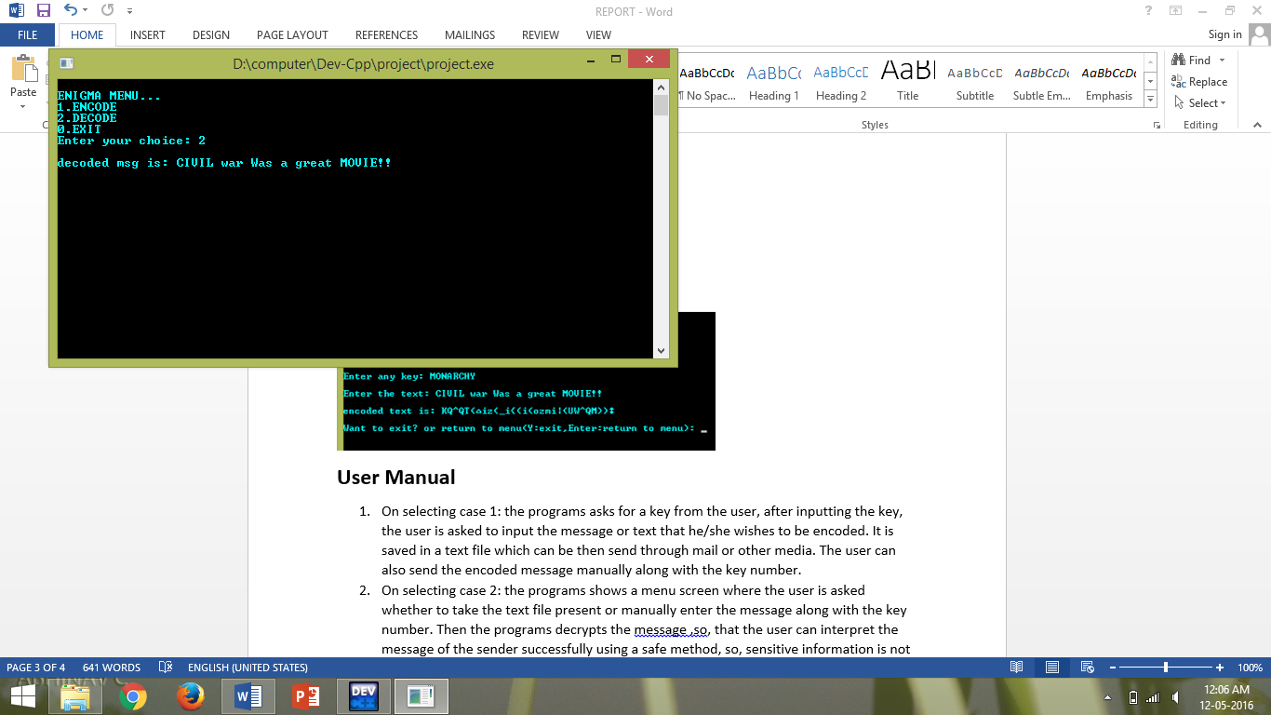

**User Manual**

1. On selecting case 1: the programs asks for a key from the user, after inputting the key, the user is asked to input the message or text that he/she wishes to be encoded. It is saved in a text file which can be then send through mail or other media.
2. On selecting case 2: the programs shows the decoded message that is stored in a text file “message.txt”, if the user wants to enter the encoded message manually, he/she can edit the contents stored in message.txt and run the program with case 2.
3. On selecting Case 0: the program exits.

**References**

1. Computer science with C++ by sumita arora
2. “ANSI C” by Balaguruswami
3. Turbo c by Moolish cooper
4. Introduction to C programming by Reema thareja
5. Let us “C” by Kanetkar

**CODE:**

/* ---------------------------------------PROJECT (BY ABHINAV CHOUDHARY,DIVYANSH KHANNA,THOMAS ABRAHAM)----------------------------------------------------------*/

//HEADER FILES USED

#include <stdio.h>

#include <stdlib.h>

#include<conio.h>

#include<windows.h>

#include<string.h>

#include<time.h>

#include<fstream>

#include <cstdlib>

#include <unistd.h>

//Functions defined

using namespace std;

void gotoxy(int,int); //gotoxy function used to set cursor to a specified position

int main()

{ int x,y,choice,len,xRan,i,sum=0,n,last; //variables defined

char key[20],c,text[100],option,t;

//title page

gotoxy(60,3);

sleep(1);

system("COLOR A");

printf("welcome");

sleep(2);

for(x=1,y=5;y<15;y++)

{ gotoxy(x, y);

system("COLOR C");

printf("E");

}

for(x=1,y=5;x<9;x++)

{ gotoxy(x, y);

system("COLOR A");

printf("E");

}

for(x=1,y=10;x<9;x++)

{ gotoxy(x, y);

system("COLOR A");

printf("E");

}

for(x=1,y=15;x<9;x++)

{ gotoxy(x, y);

system("COLOR A");

printf("E");

}

sleep(1);

for(x=11,y=15;y>=5;y--)

{ gotoxy(x,y);

system("COLOR B");

printf("N");

}

for(x=11,y=5;x<=21,y<=15;x++,y++)

{ gotoxy(x,y);

system("COLOR B");

printf("N");

}

for(x=21,y=15;y>=5;y--)

{ gotoxy(x,y);

system("COLOR B");

printf("N");

}

sleep(1);

for(x=23,y=5;x<=32;x++)

{ gotoxy(x,y);

system("COLOR C");

printf("I");

}

for(x=28,y=5;y<=15;y++)

{ gotoxy(x,y);

system("COLOR C");

printf("I");

}

for(x=23,y=15;x<=32;x++)

{ gotoxy(x,y);

system("COLOR C");

printf("I");

}

sleep(1);

for(x=43,y=5;x>=38;x--)

{ gotoxy(x,y);

system("COLOR D");

printf("G");

}

for(x=38,y=5;x>=31,y<=10;x--,y++)

{ gotoxy(x,y);

system("COLOR D");

printf("G");

}

for(x=32,y=11;x<=38,y<=15;x++,y++)

{ gotoxy(x,y);

system("COLOR D");

printf("G");

}

for(x=37,y=15;x<=43;x++)

{ gotoxy(x,y);

system("COLOR D");

printf("G");

}

for(x=43,y=15;y>10;y--)

{ gotoxy(x,y);

system("COLOR D");

printf("G");

}

for(x=43,y=11;x>=38;x--)

{ gotoxy(x,y);

system("COLOR D");

printf("G");

}

for(x=43,y=11;x<=45;x++)

{ gotoxy(x,y);

system("COLOR D");

printf("G");

}

for(x=45,y=11;y<=15;y++)

{ gotoxy(x,y);

system("COLOR D");

printf("G");

}

sleep(1);

for(x=47,y=15;y>=5;y--)

{ gotoxy(x,y);

system("COLOR F");

printf("M");

}

for(x=47,y=5;x<=52,y<=10;x++,y++)

{ gotoxy(x,y);

system("COLOR F");

printf("M");

}

for(x=52,y=10;x<=57,y>=5;x++,y--)

{ gotoxy(x,y);

system("COLOR F");

printf("M");

}

for(x=57,y=5;y<=15;y++)

{ gotoxy(x,y);

system("COLOR F");

printf("M");

}

sleep(1);

for(x=59,y=15;x<=69,y>=5;x++,y--)

{ gotoxy(x,y);

system("COLOR E");

printf("A");

}

for(x=69,y=5;x<=79,y<=15;x++,y++)

{ gotoxy(x,y);

system("COLOR E");

printf("A");

}

for(x=64,y=10;x<=74;x++)

{ gotoxy(x,y);

system("COLOR E");

printf("A");

}

sleep(1);

gotoxy(1,18);

system("COLOR 9");

printf("MINI");

sleep(1);

gotoxy(64,18);

printf("VERSION 1.2.0");

sleep(1);

gotoxy(1,20);

system("COLOR B");

sleep(1);

printf("PRESS ANY KEY TO CONTINUE.........................");

getch();

//main program begins....

label:

system("cls");

printf("\nENIGMA MENU...\n1.ENCODE\n2.DECODE\n0.EXIT\nEnter your choice: ");

scanf("%d",&choice);

switch(choice)

{ case 1: { ofstream fout; //opening the file for writing

fout.open("message.txt",ios::out);

printf("\nEnter any key: "); //inputting the key

getchar();

fgets(key,20,stdin);

len=strlen(key); //length of the key

srand(time(NULL));

xRan=rand() % len; //randomly selecting any character from the key

c= key[xRan];

n=c; //converting into ASCII

while(n>0)

{

last = n % 10; // Obtain Last Digit Of Number

sum = sum + last; // Add Obtained Digit to Number

n = n /10; // Remove Last Digit From Number

}

if(sum>=10)

{ int num=sum;

sum=0;

while(num>0)

{

last = num % 10; // Obtain Last Digit Of Number

sum = sum + last; // Add Obtained Digit to Number

num = num /10; // Remove Last Digit From Number

}

}

printf("\nEnter the text: ");

fgets(text,100,stdin); //inputting the message

len=strlen(text); //finding the length of the text

for(i=0;i<len;i++)

text[i]=text[i]+sum; //encoding the message using key

printf("\nencoded text is: %s",text);

fout<<sum<<"\n"<<text<<"\n";

fout.close(); //closing previously opened file

printf("\n\nWant to exit? or return to menu(Y:exit,Enter:return to menu): ");

scanf("%c",&option);

if(option=='y'||option=='y') //exiting

exit(0);

else

goto label; //returning to menu if exit is not executed

break;

}

case 2:{

ifstream fin("message.txt",ios::in); //opening file to read from

fin.seekg(0);

fin>>sum;

i=0;

while(!fin.eof()) //decoding the message

{ fin>>t;

text[i]=t-sum;

i++;

}

printf("\ndecoded msg is: %s",text);

fin.close(); //closing the file

break;

}

case 0: printf("\nEXITING......"); //exiting

sleep(1);

exit(0);

break;

default:printf("\nSorry, wrong input"); //default case

break;

}

getch();

return 0;

}

//function definition

void gotoxy(int x, int y) //to set cursor position to a specified point in x-y axis

{

static HANDLE h = NULL;

if(!h)

h = GetStdHandle(STD_OUTPUT_HANDLE);

COORD c = { x, y };

SetConsoleCursorPosition(h,c);

}

//-----------------------------------------------------END OF PROGRAM-----------------------------------------------------------------------------------------